Newsletter~
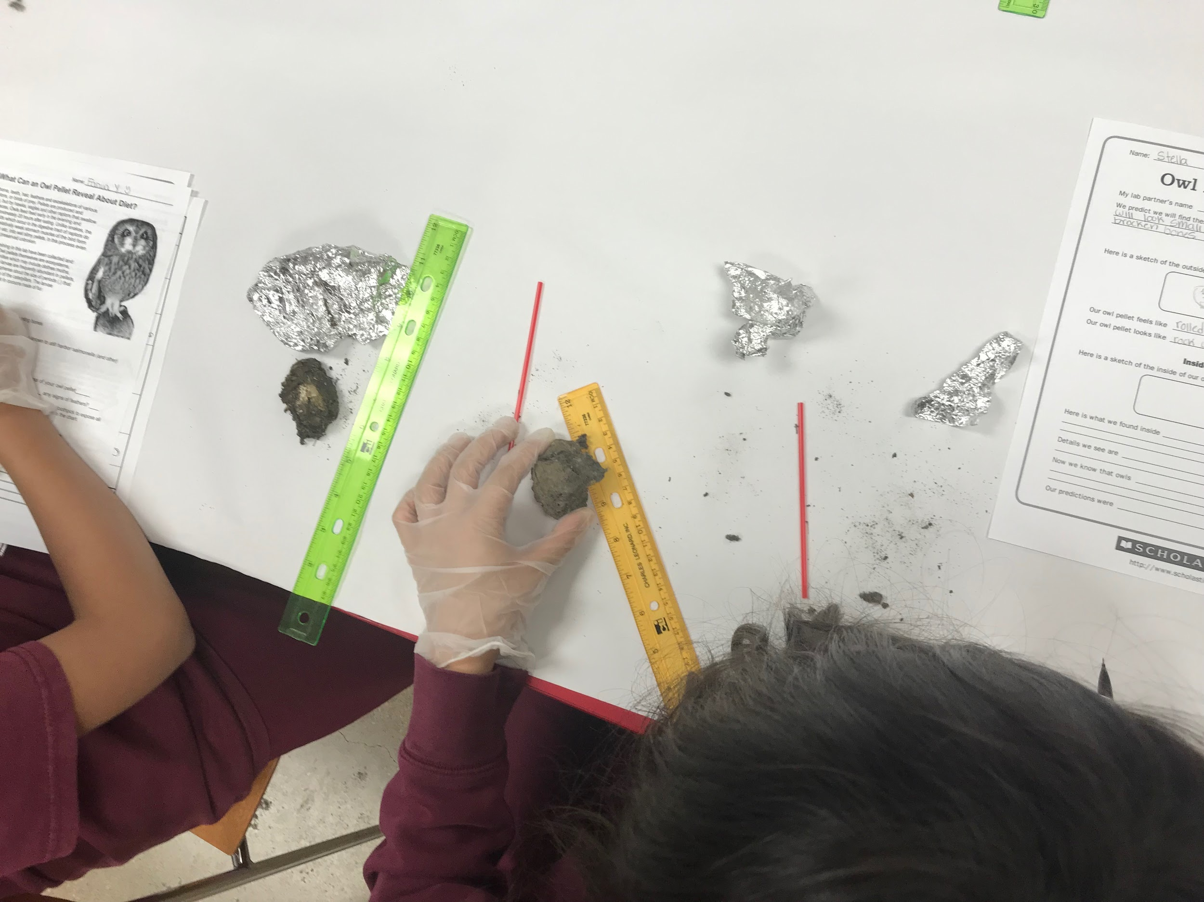
Week of May 21-25

Math~
With our final full week, the students had their final review of all the new math concepts they have learned this year. At the end of the week the students were able to show all their knowledge and express their understanding of each concept.

Science (Anatomy)~
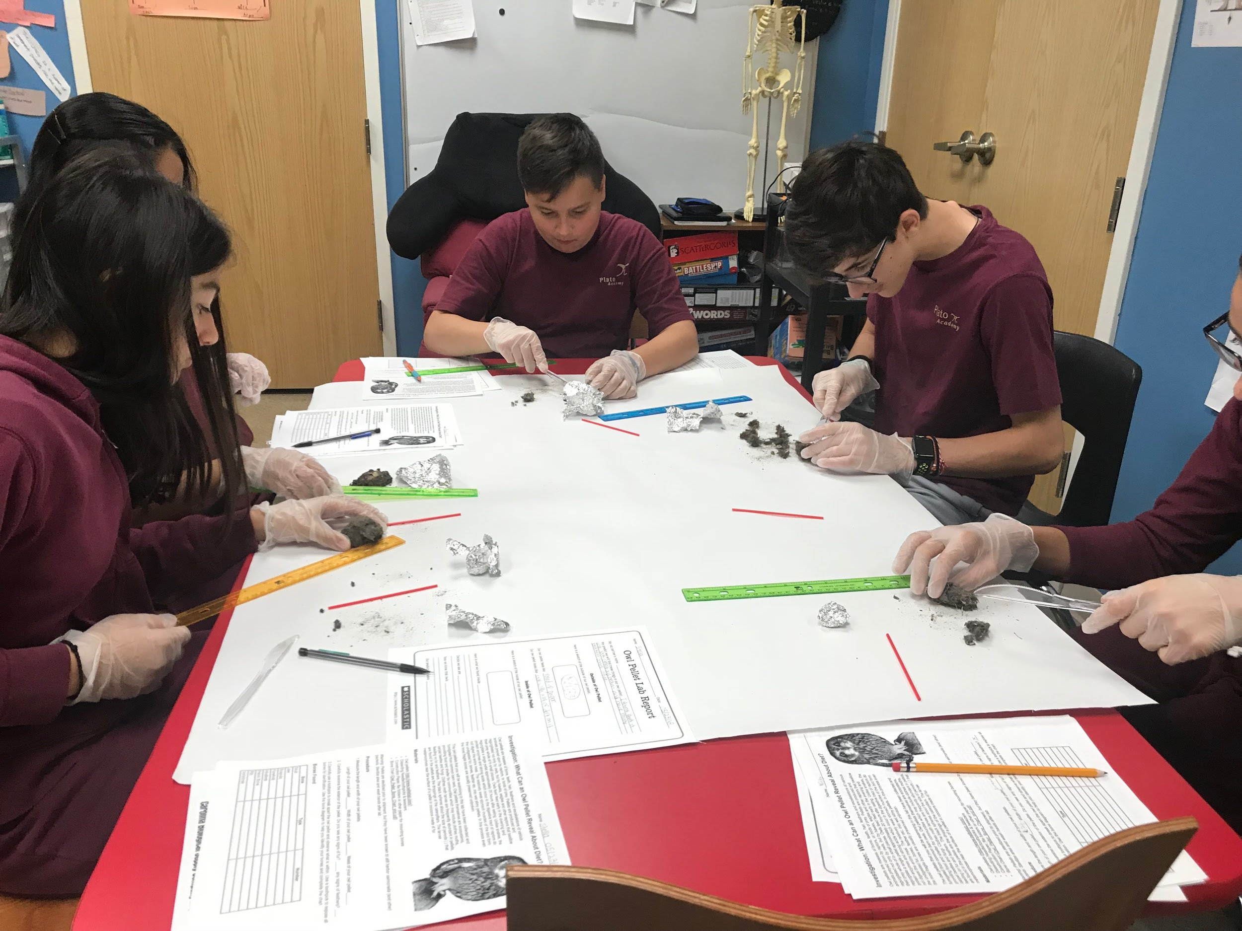
On Wednesday, the students had their final lab! The students were given the opportunity to dissect owl pellets. This was definitely one of the most fun experiences the student and I have shared this year, just watching them dissect and really focus on what they were doing was fun. All of the students took their time, dissecting and analyzing each bone or piece of fur found within their pellet. It was fun for the students to see the difference between each of their pellets as well gaining experience in an actual lab report. I am hoping that by doing labs such as these the students will be better prepared for their high school science courses as well as the work that is involved within the process.
~ The owl pellet experiment gave the students a chance to take their knowledge from anatomy and put it to use while dissecting and interpreting what bones belong to which animals!

Final Projects~
Throughout the week the students were given the opportunity to work in class on their final models/ interactive activity for their peers.
~Projects are due on Wednesday (5/30/18)

Graduation~
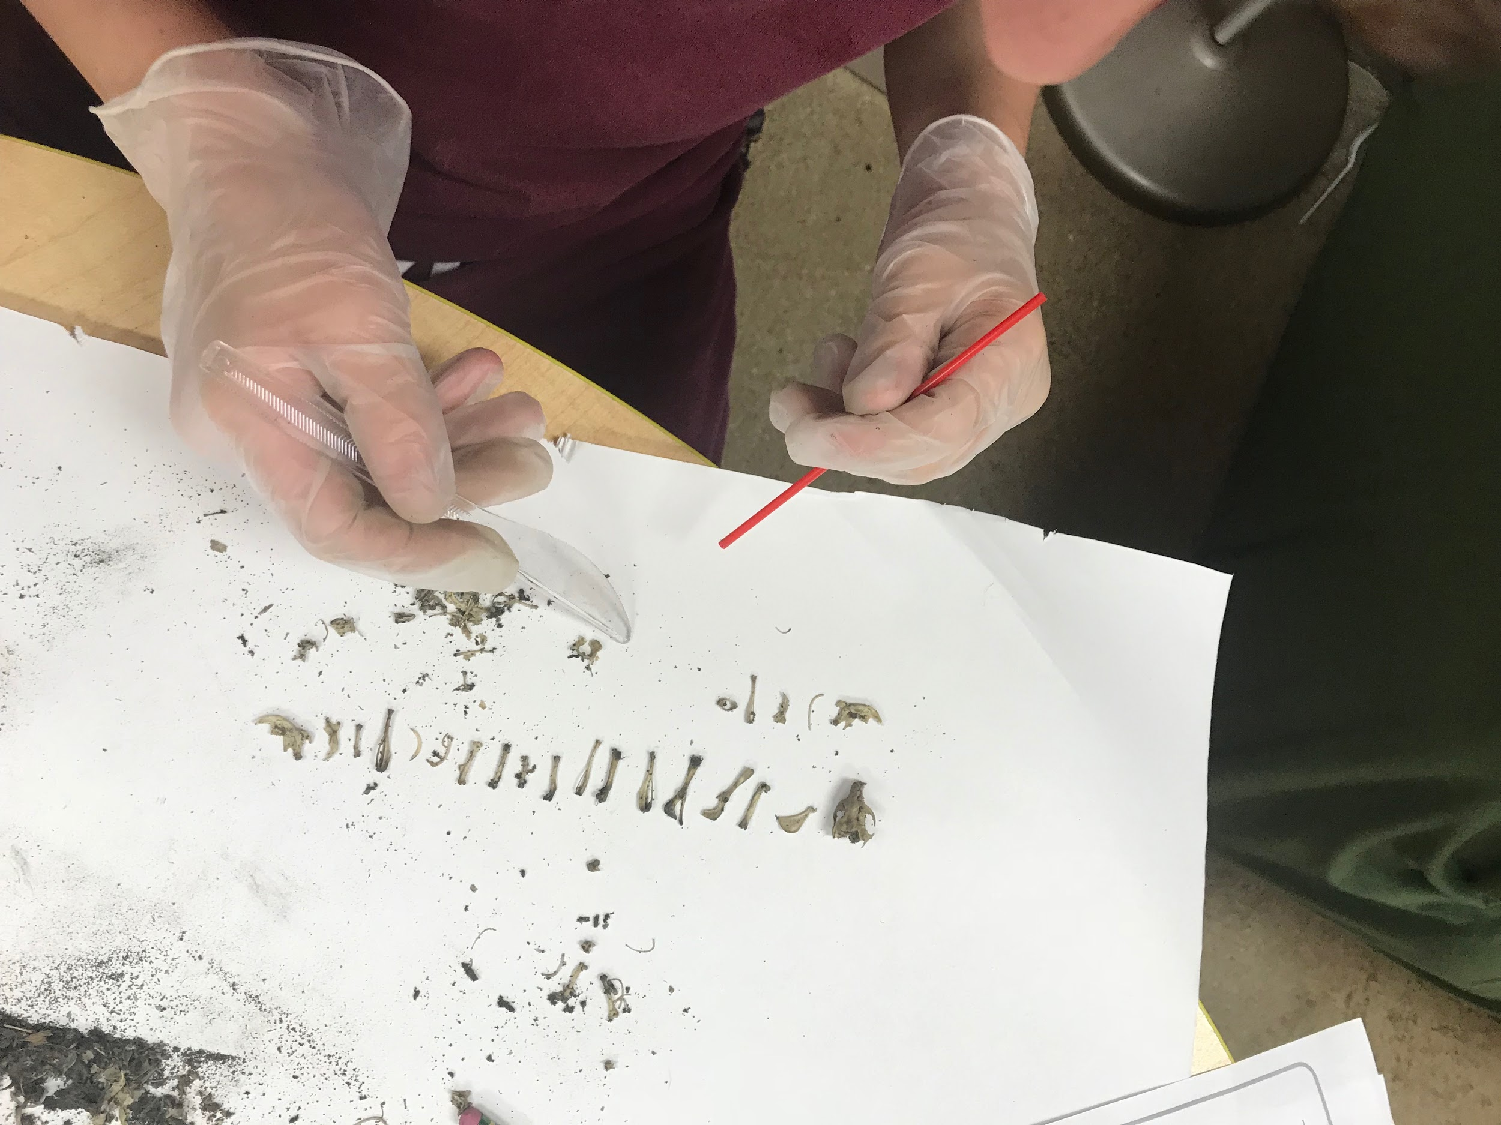
On Thursday we all watched as three of our friends/ students walked across the stage and graduated 8th grade! It was an emotional day but filled with love and excitement for our fellow room 2 students! We hope for nothing but the best for all three of the students and hope their high school careers are fun and exciting!

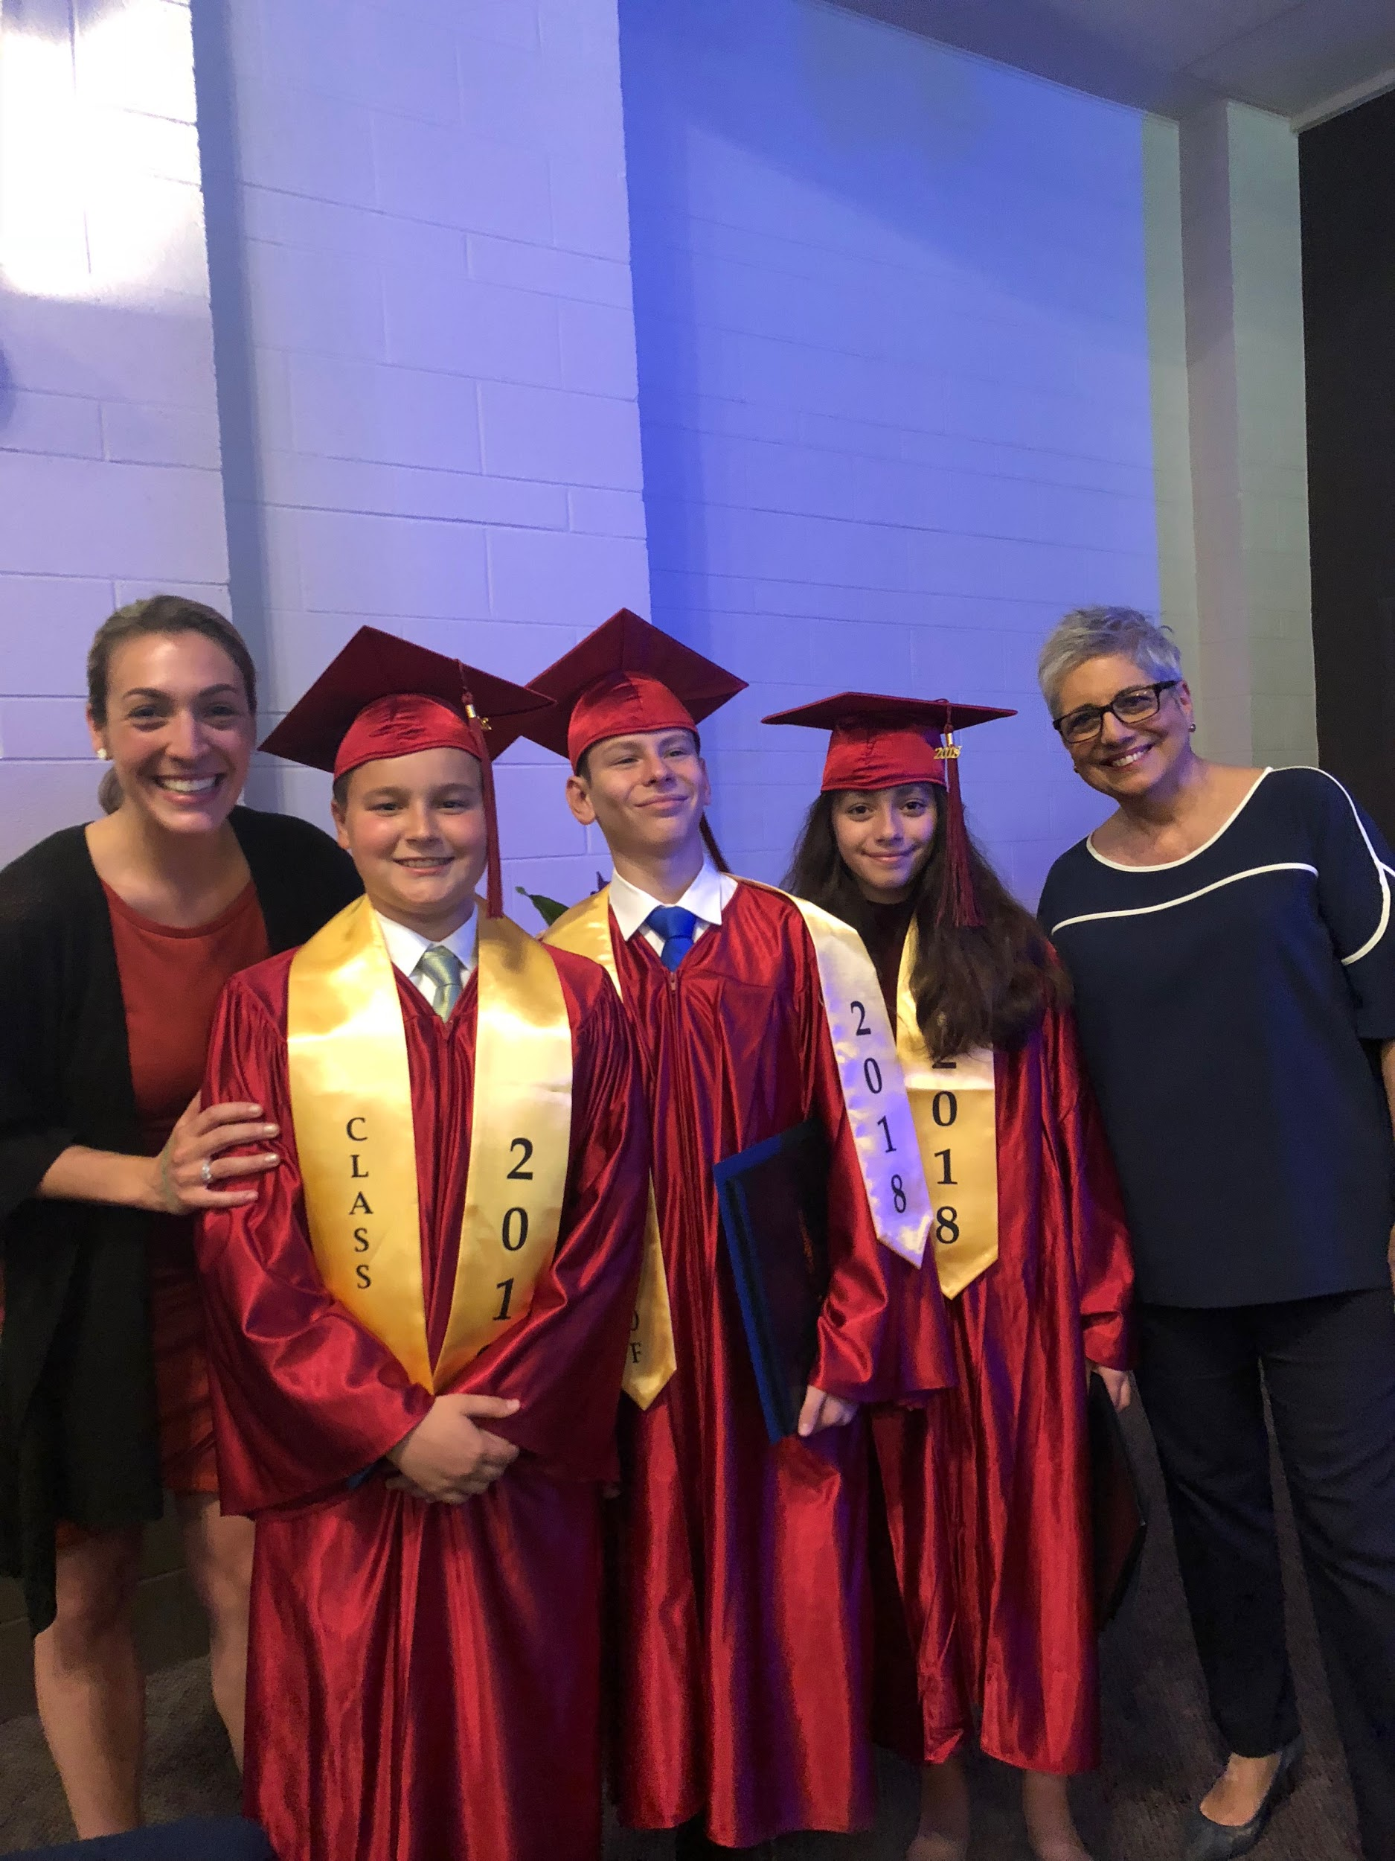
Reminders:
Monday (5/28)- No School!
Tuesday (5/29) - Field Day
Wednesday (5/30) - Finals Due/ Practice for Program
Thursday (5/31)- End of Year clean out/ Party
Friday (6/1)- End of the year program 10 am @ The Bridge

Hope you have a great long weekend,
Ms. Alexandra

