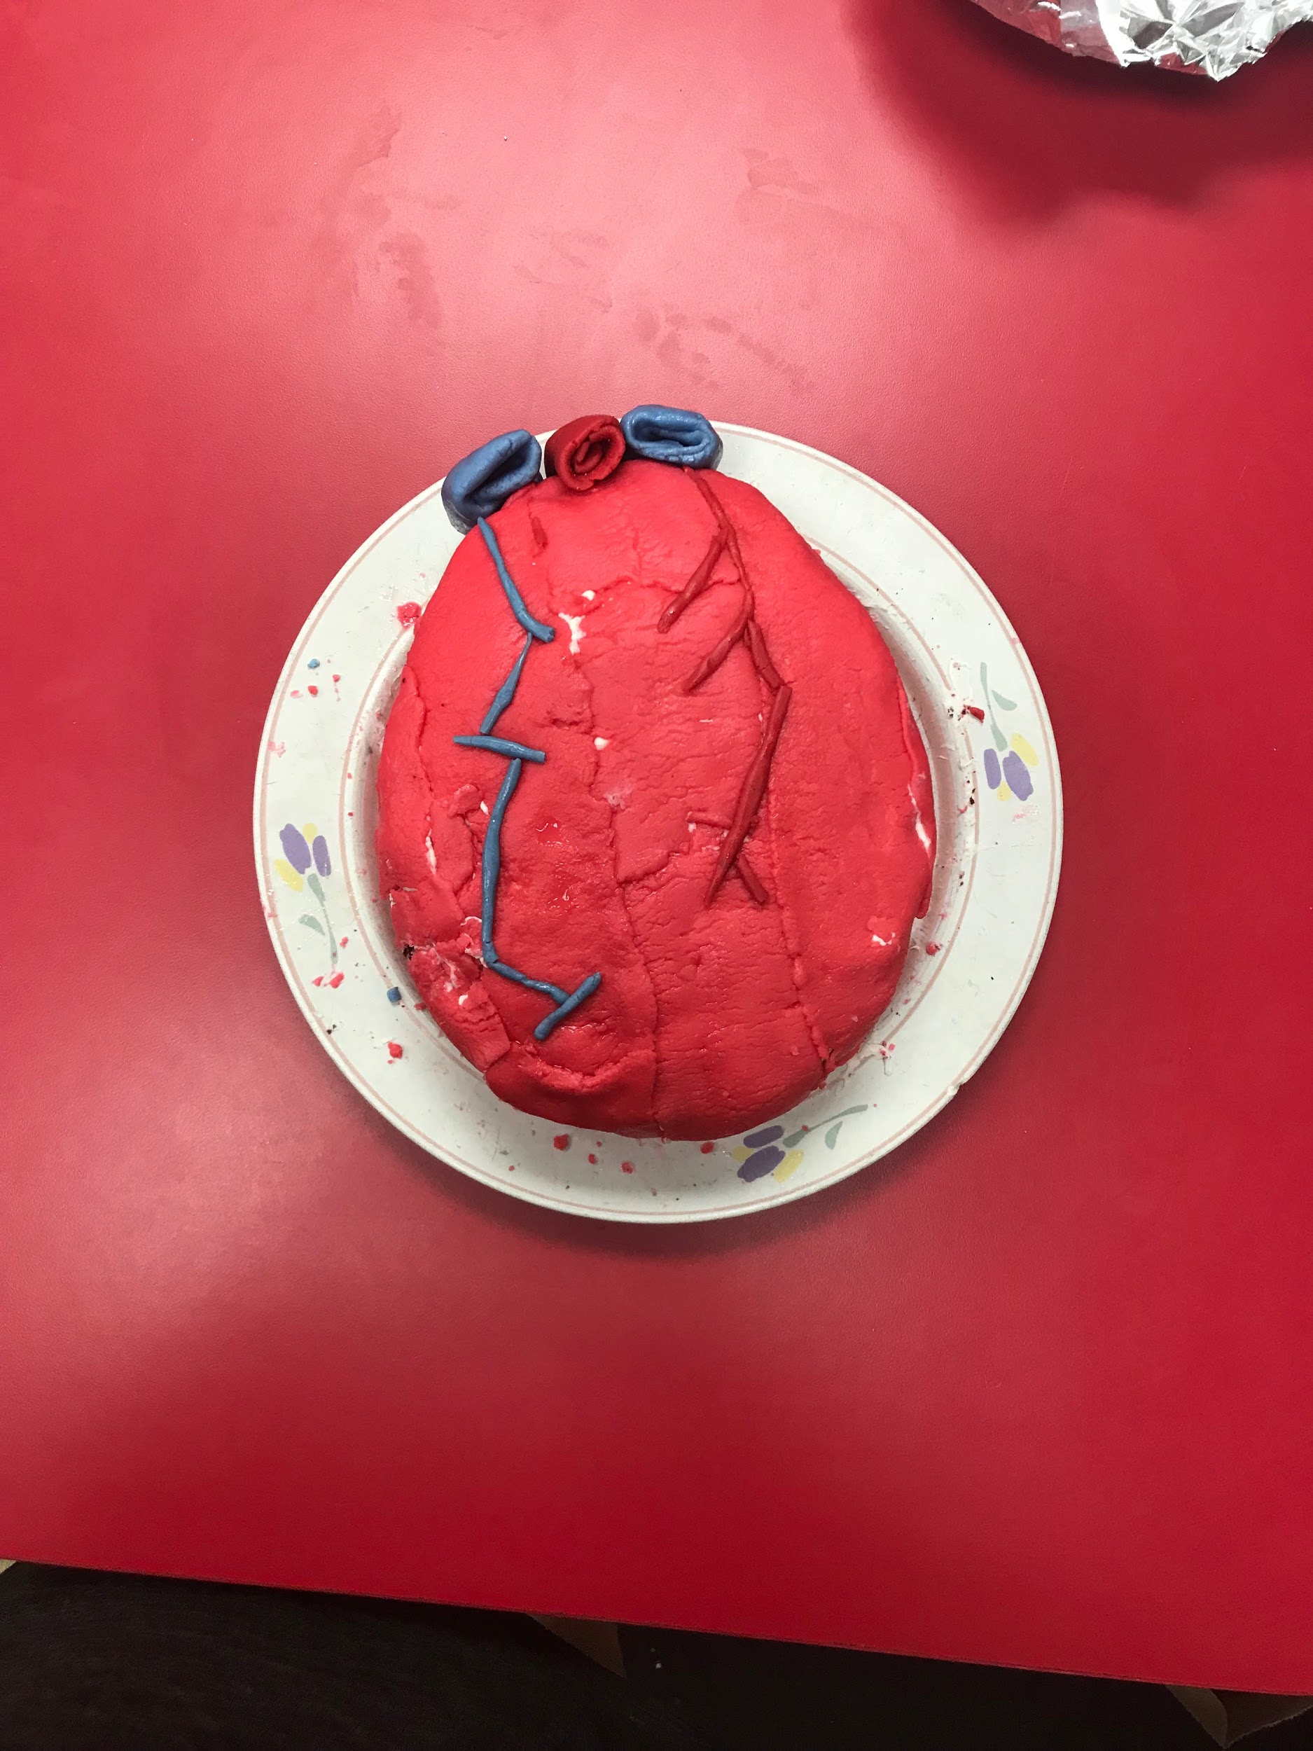
Final Newsletter!

~ As days are coming to an end and summer is approaching the students and I wrapped up all explorations that we covered throughout the entire year. We reviewed and assessed our understanding of each and every math concept, we were able to go back and identify and explain main topics from the Renaissance and lastly we were able to present our end of the year finals with our anatomy final projects.

~ On our final day at Plato we received letters recognizing that 6 of our students have been nominated and registered in the American Library of Poetry Contest. They each have the opportunity to make it to the final round and win up to $500!

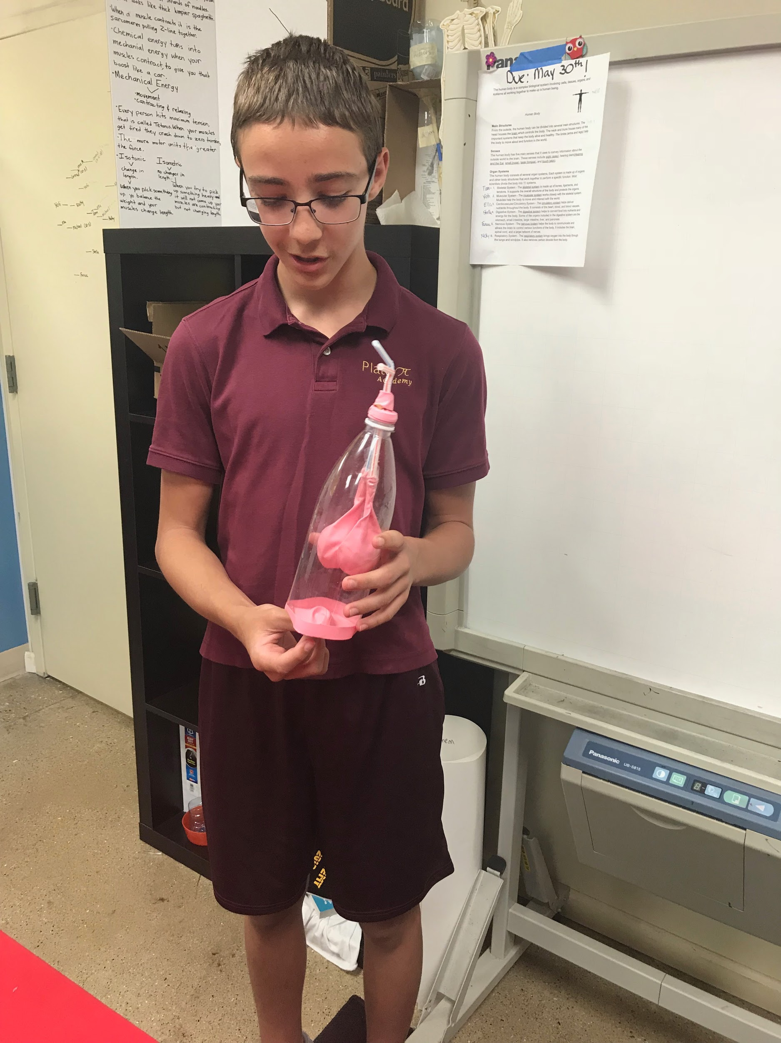
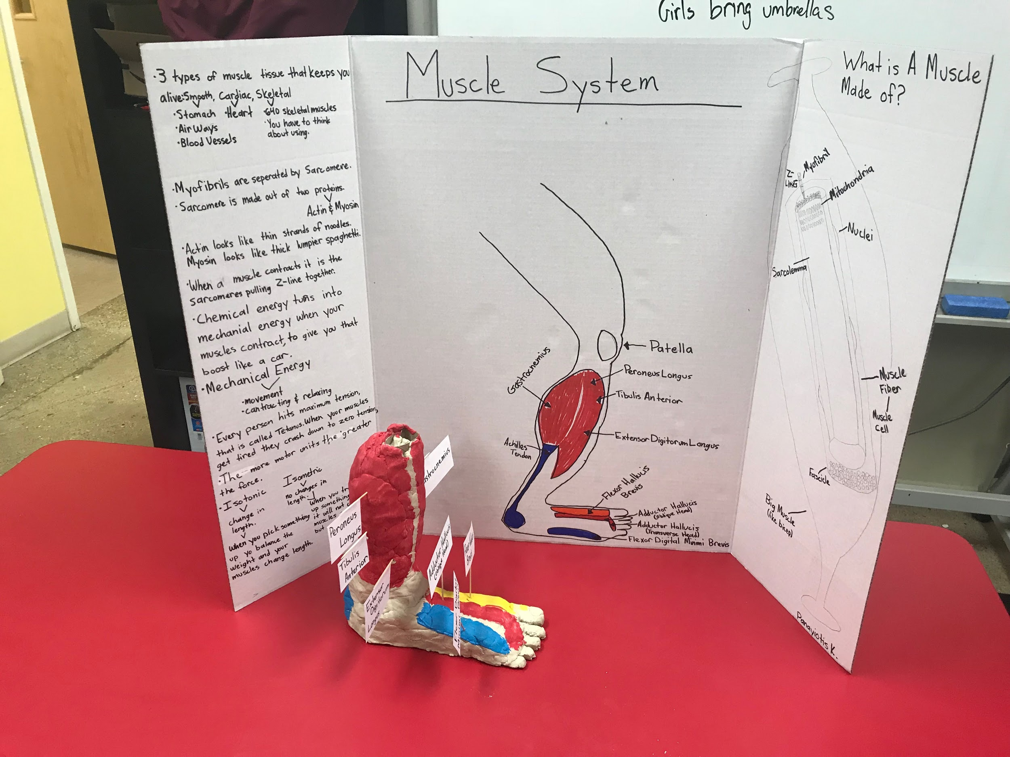
*Below are pictures of our anatomy finals, I am truly impressed with each students efforts in creating a realistic model of our bodies internal systems.
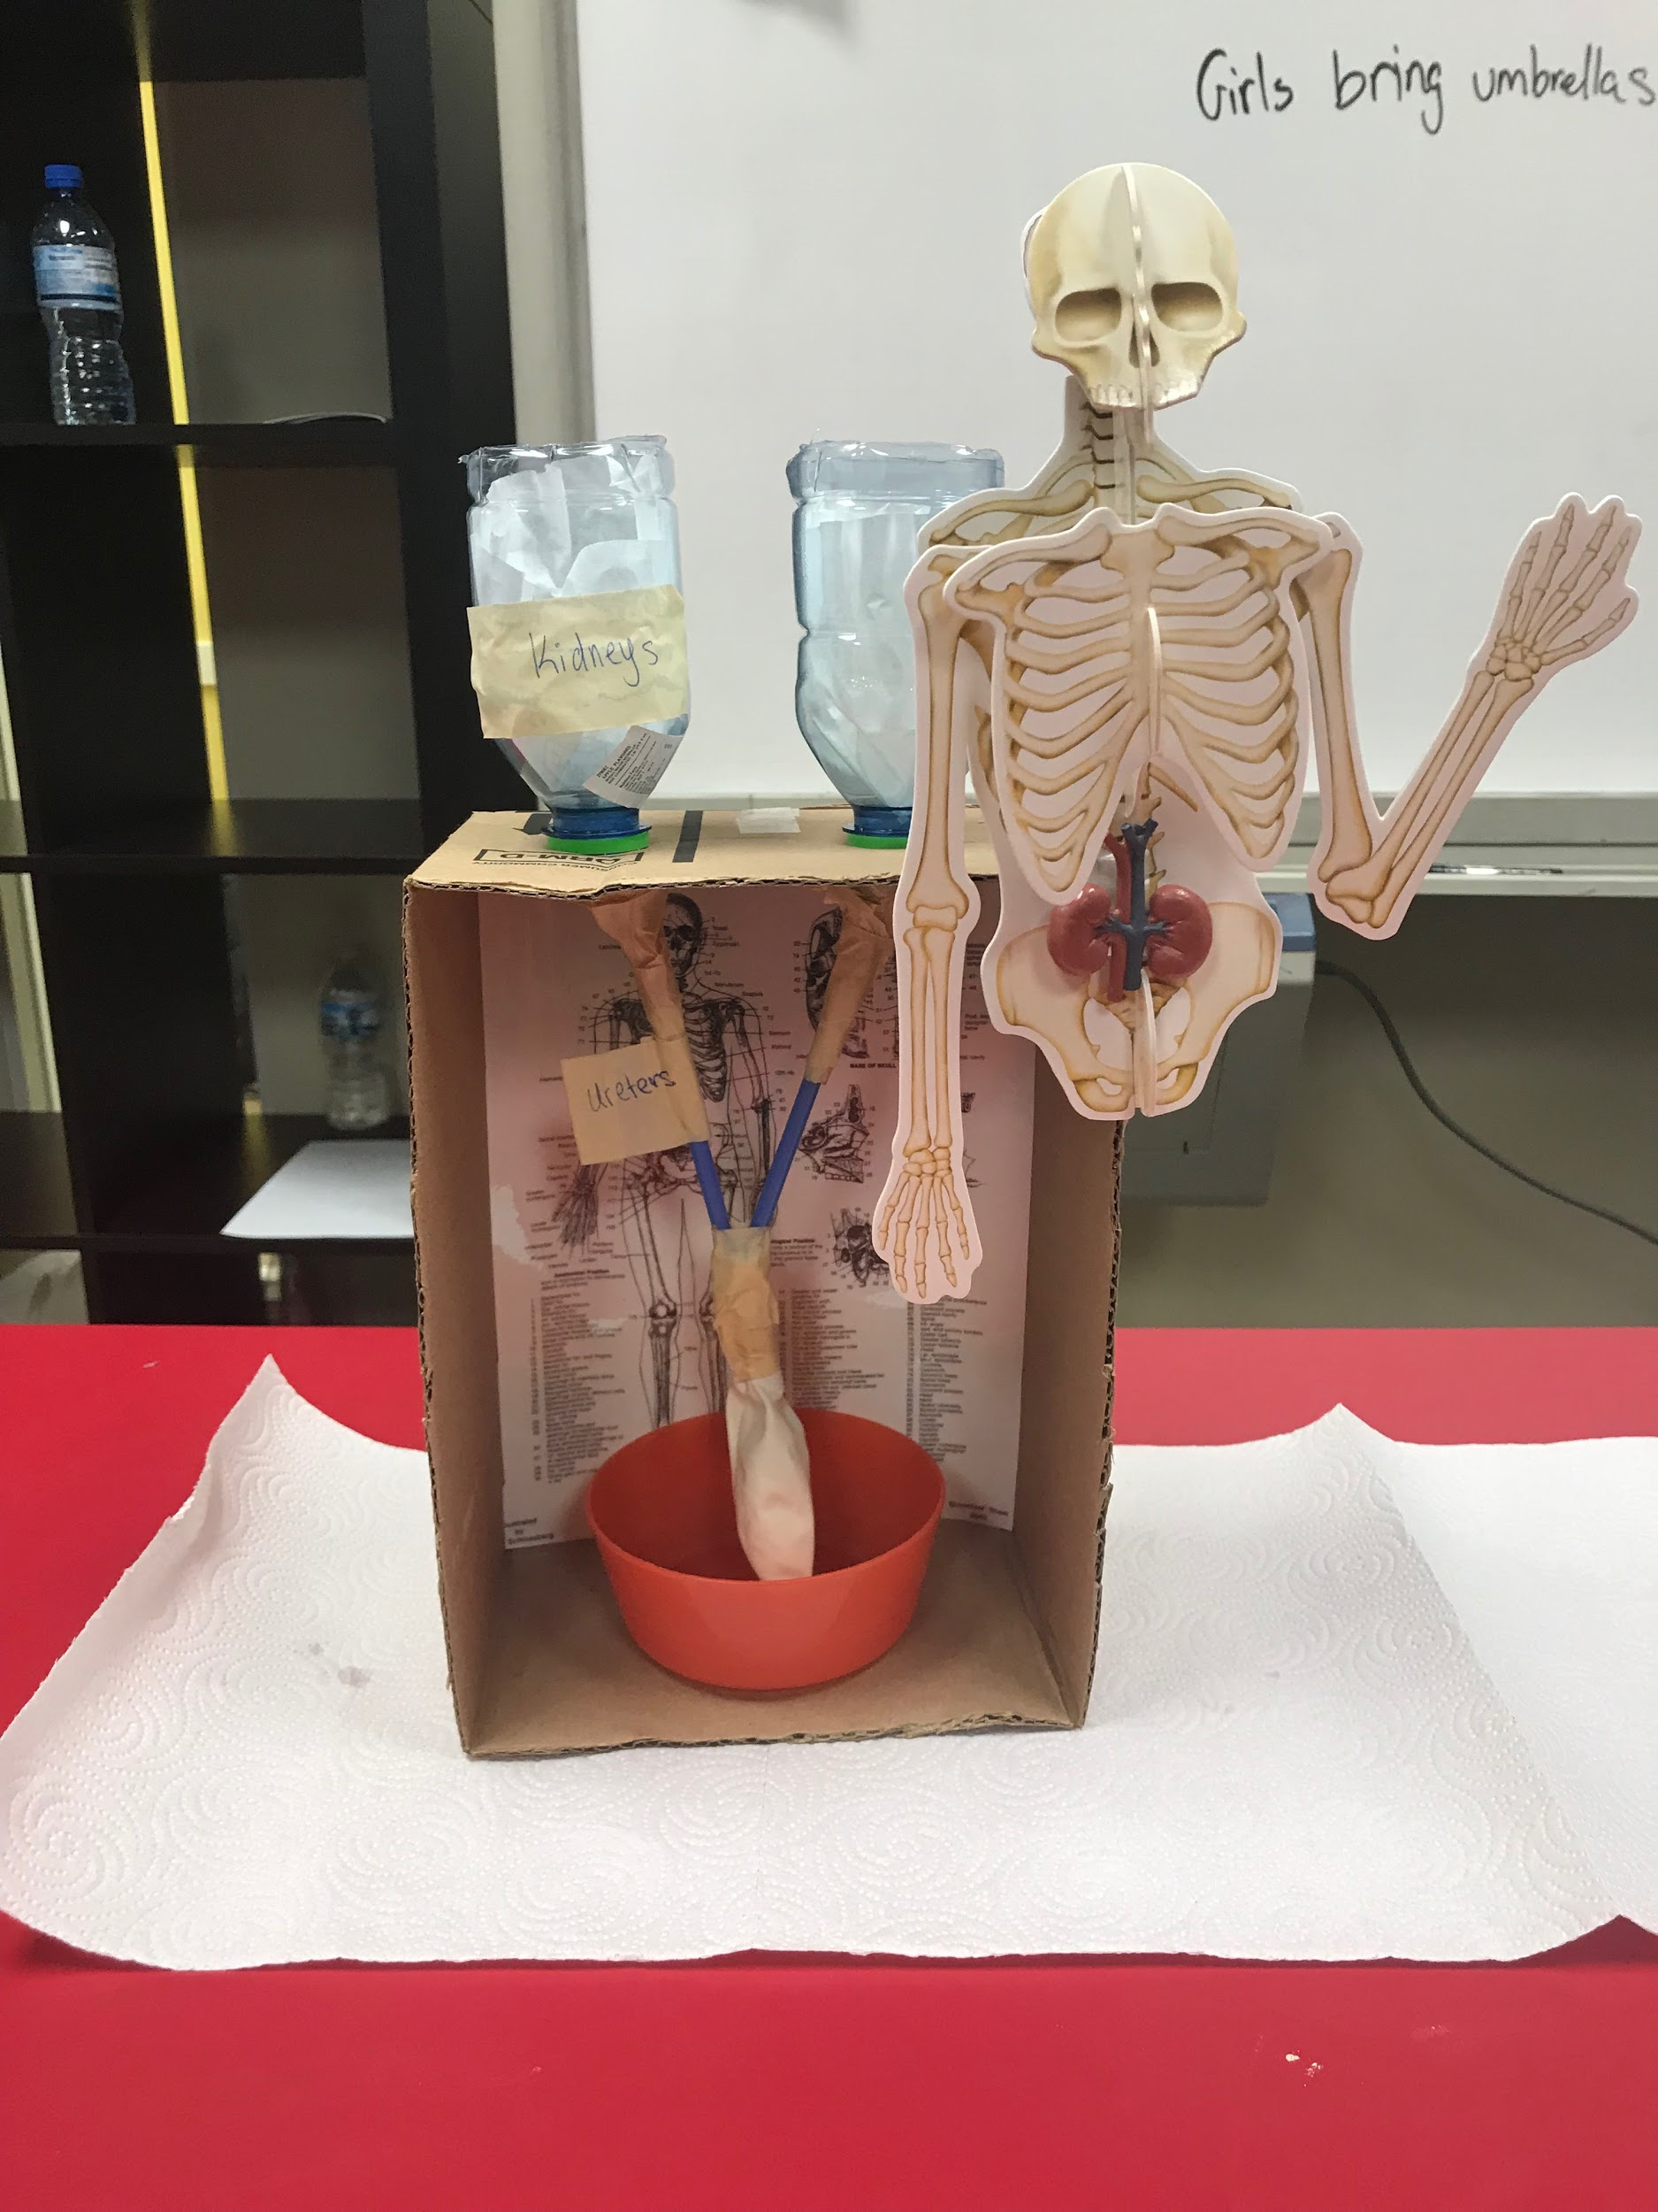
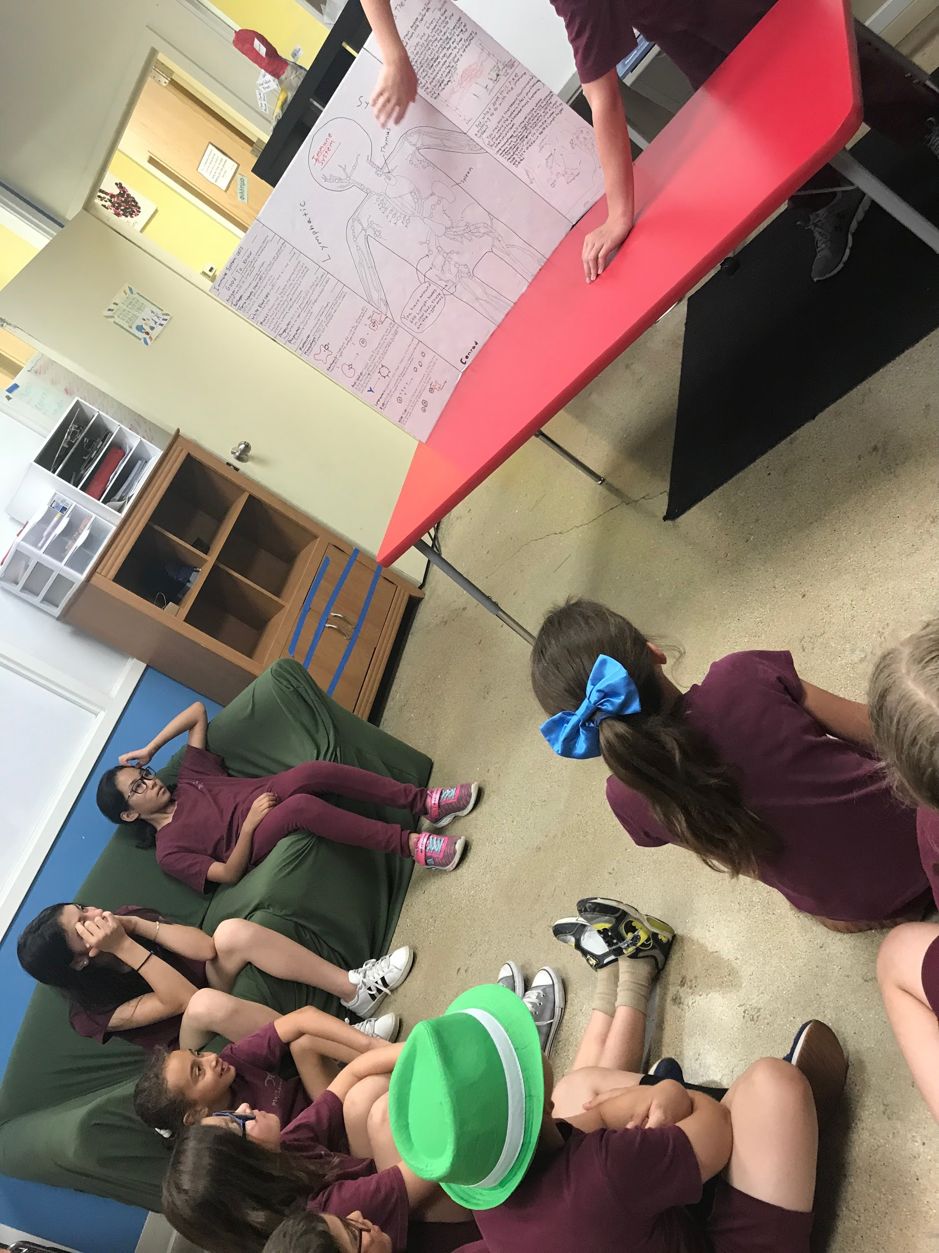
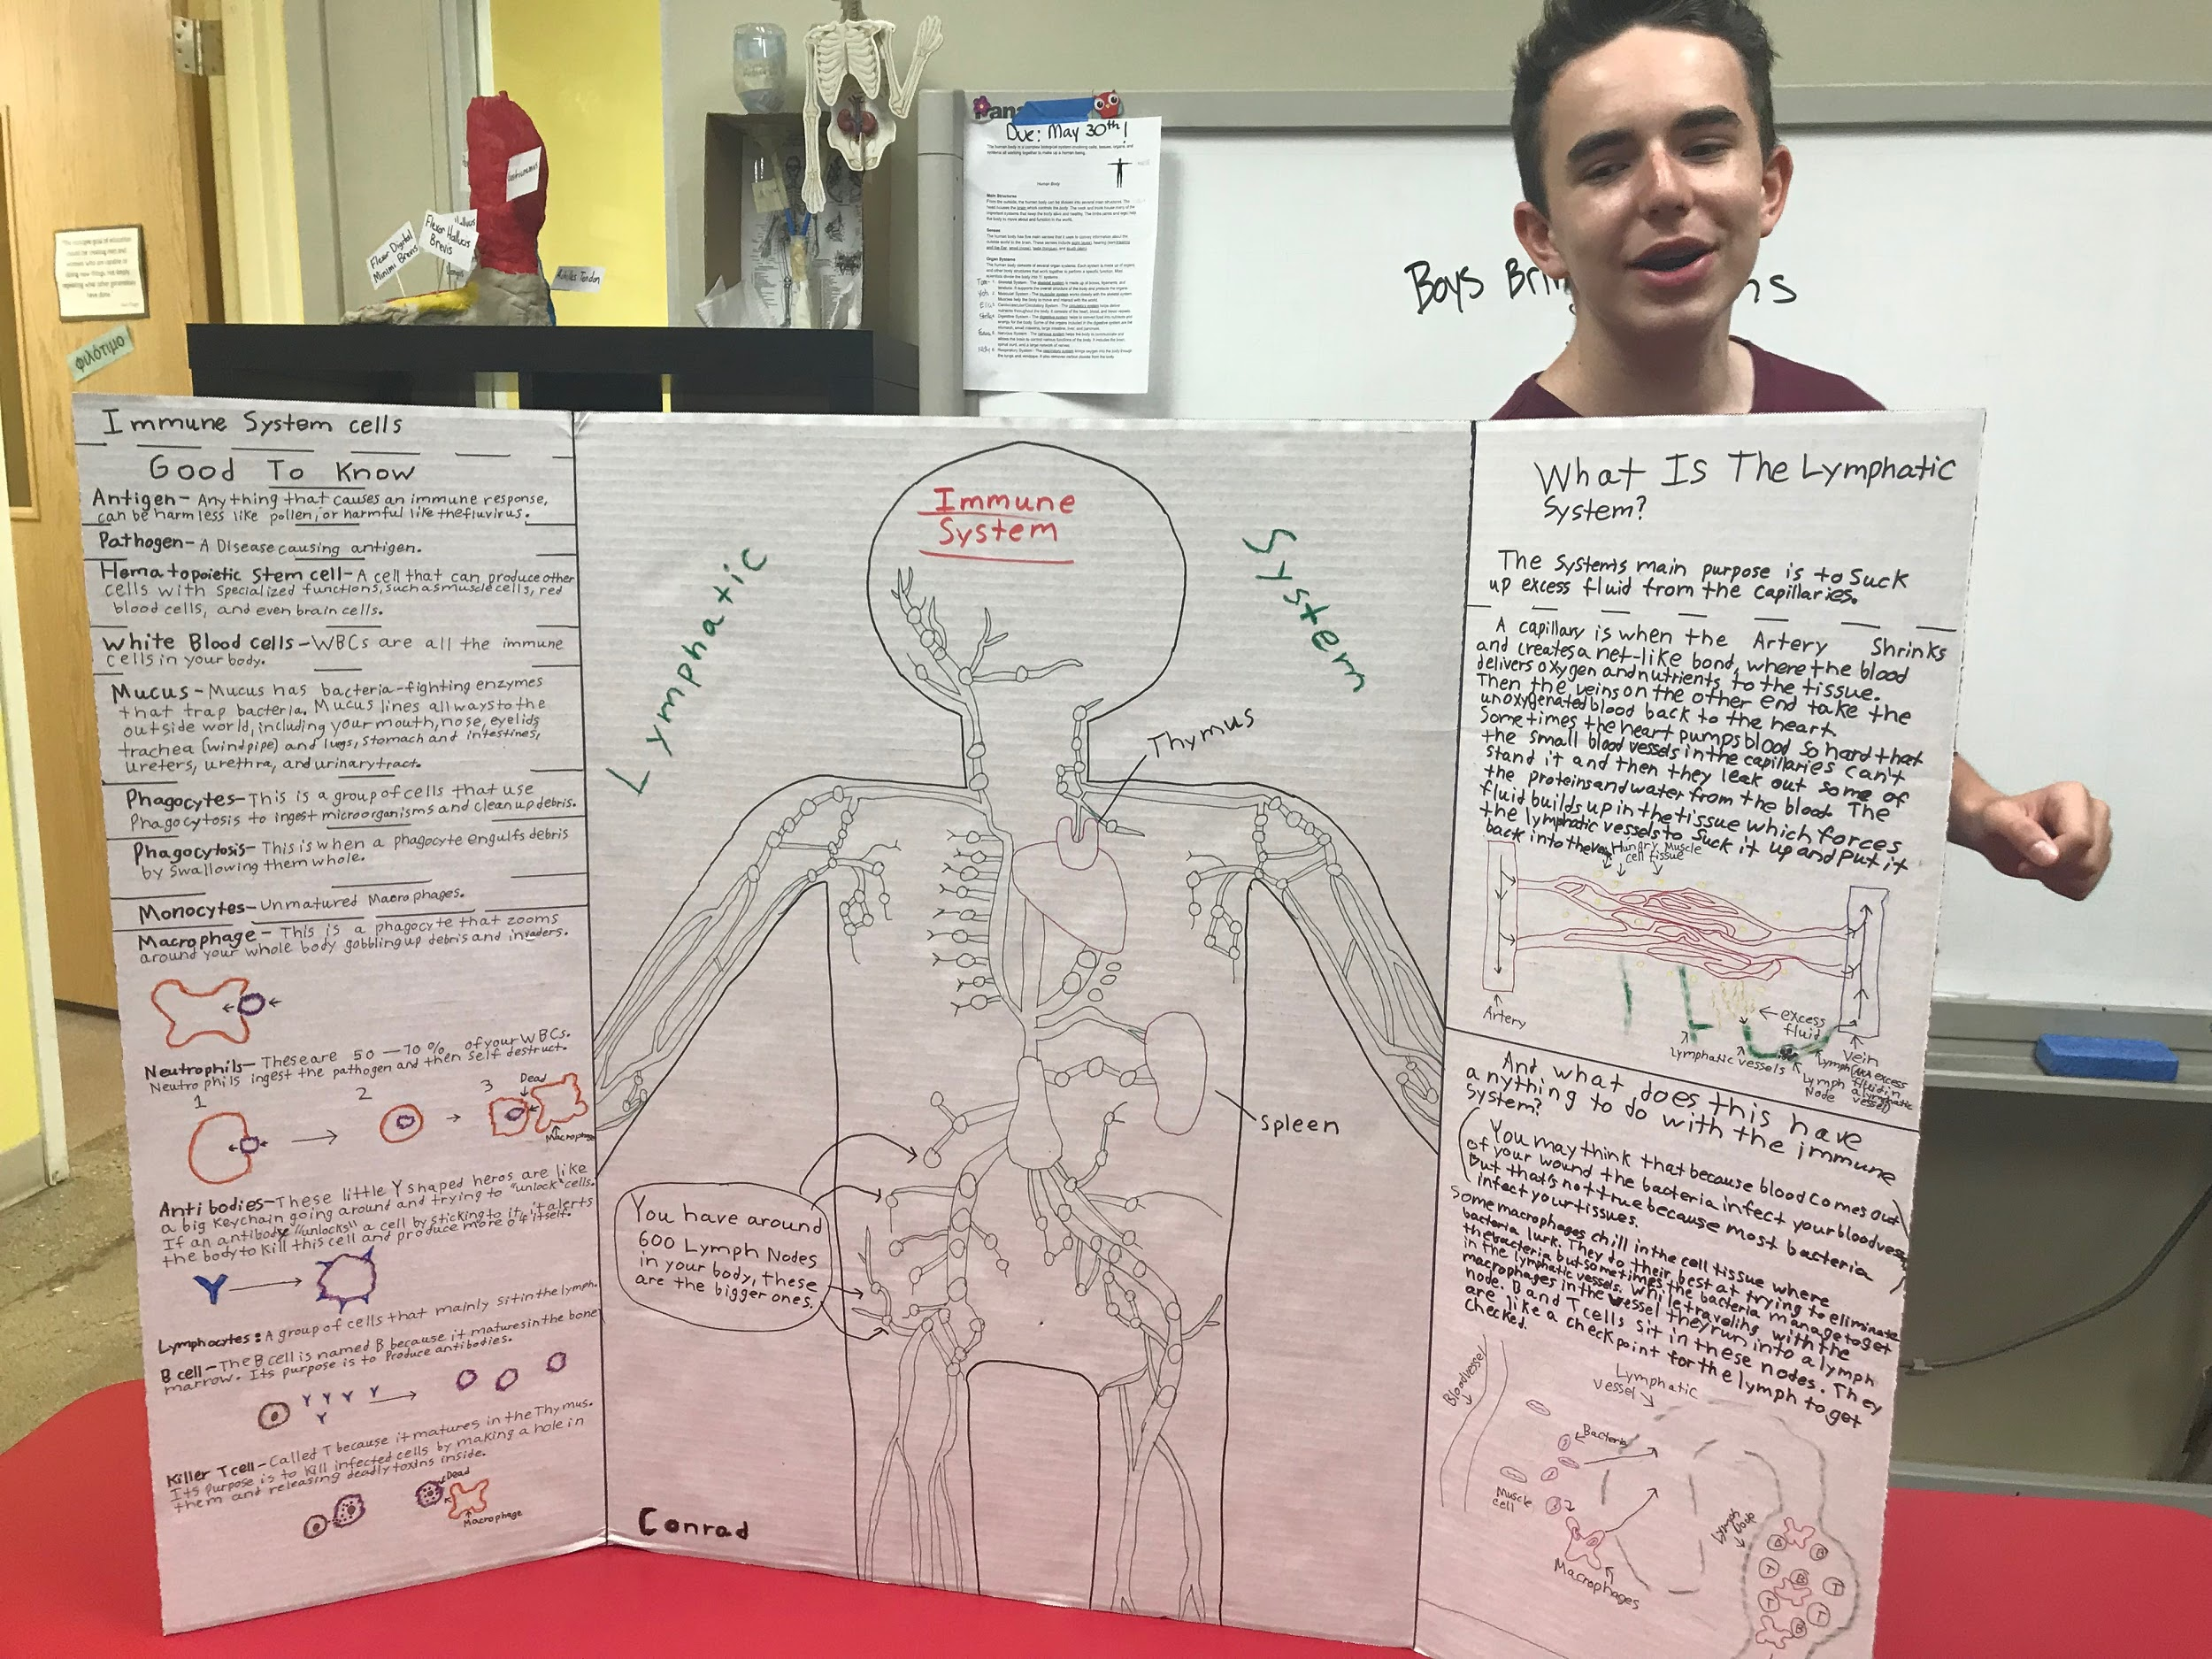

~I hope that all of room 2 students and families have a wonderful summer break. To our graduates, we are all very proud of you and hope for a successful freshman year! See the rest of you on August 21, do not forget to read you summer reading novel (The Phantom Tollbooth).

The MORE that you read, the MORE things you will KNOW. The MORE that you LEARN, The more PLACES you'll GO.
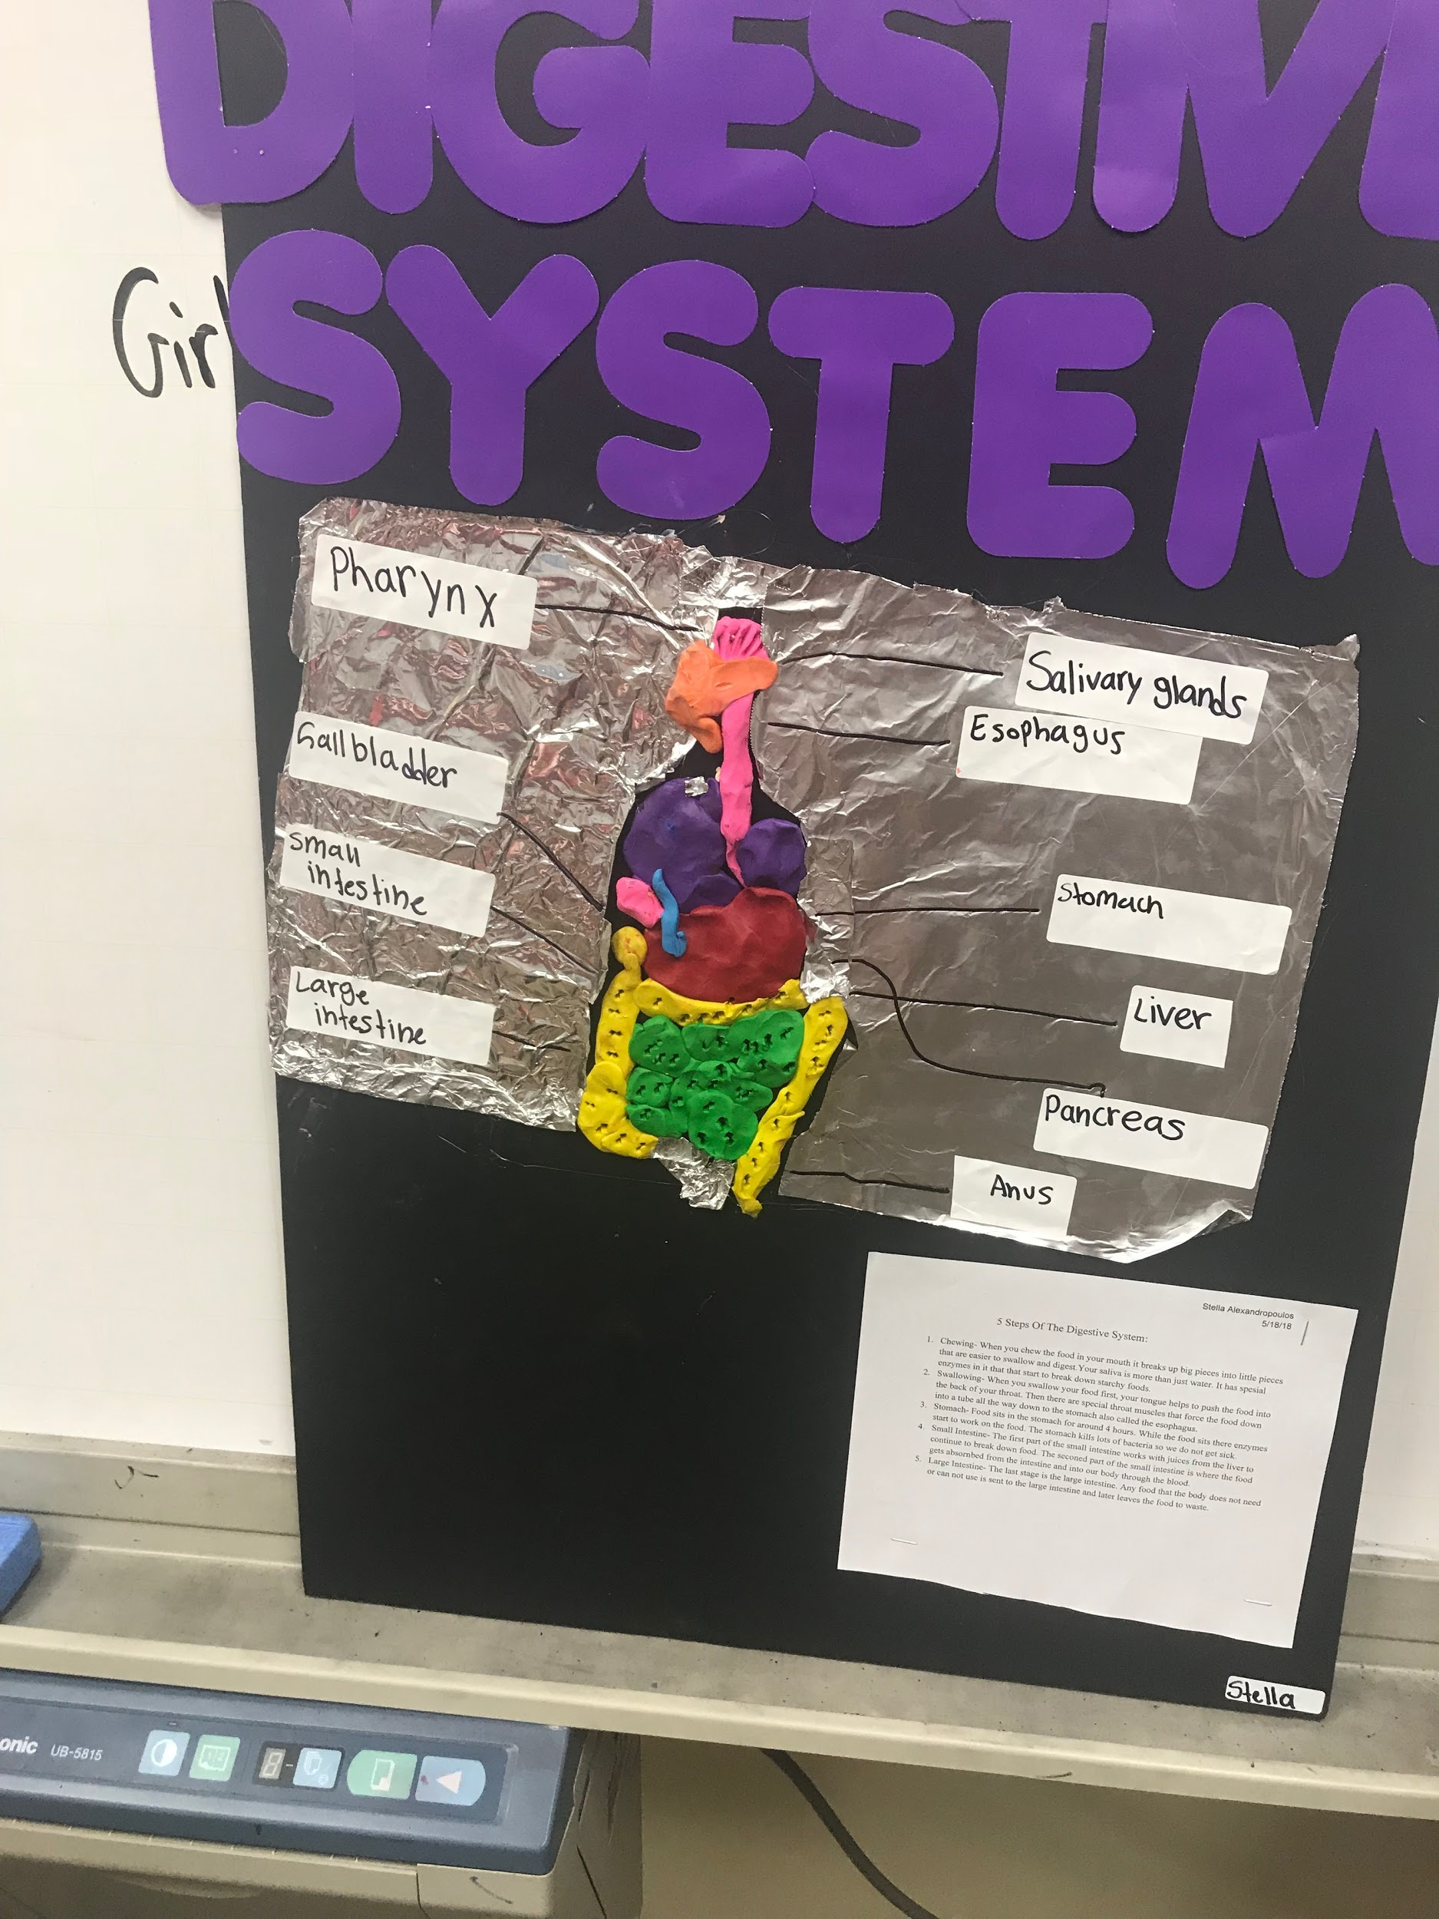
~ Dr. Seuss

