BIENVENIDOS

Hola Niños y Padres de familia!

Hello children and Parents! Me llamo Soraya Castro, and I am so excited to be your Spanish teacher this year. I love to learn about other cultures, and I hope I inspire my students to learn about mine. We are going to do so many fun activities, and of course, we will learn a lot. We are going to learn Spanish through fun games, songs, stories and crafts.
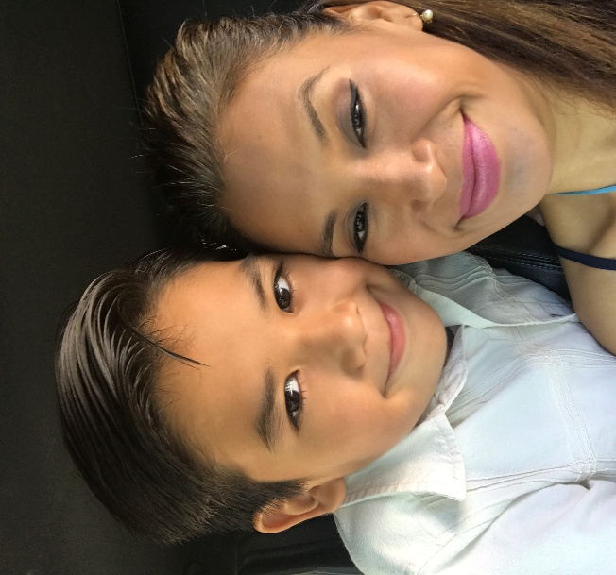
I’ve had a fabulous summer and I can’t wait to hear all about yours.

Conóceme / Meet me
When I was 9 years old, I knew that I wanted to become a teacher, and I did! I majored in Early Childhood Education in college, and I started as a kindergarten teacher back home in Mexico. Then I got the best job as a Spanish teacher at Plato Academy in 2014. Here, I met the most amazing staff of people dedicated to educating and nurturing children. Working at Plato has enable me to meet so many amazing kids and their families.
Here are a few of my favorite things…
Estación : Primavera / Spring
Color: Azul / blue
Libro : “The Little Prince” by Antoine de Saint-Exupéry
Bebida : Café y té Verde / coffee and green tea

Pasatiempo : Leer, dormir y disfrutar a mi familia / Reading, sleeping and spending time with my family.
Conoce a mi familia / Meet my family
Amo a mi familia. I love my family. This is my 9-year-old and fourth grader, Gael. Together we enjoy singing, swimming and dancing. Our favorite thing to do is playing hide and seek. You’ll meet him soon if you haven’t already.
I am happy to share a little bit of me with you and I hope you will share with me too.
Hasta pronto! / See you soon!
Soraya

