Newsletter 8-25-17
Welcome to room 2, this year we are a total of nine students in the middle grade classroom.
Eclipse~
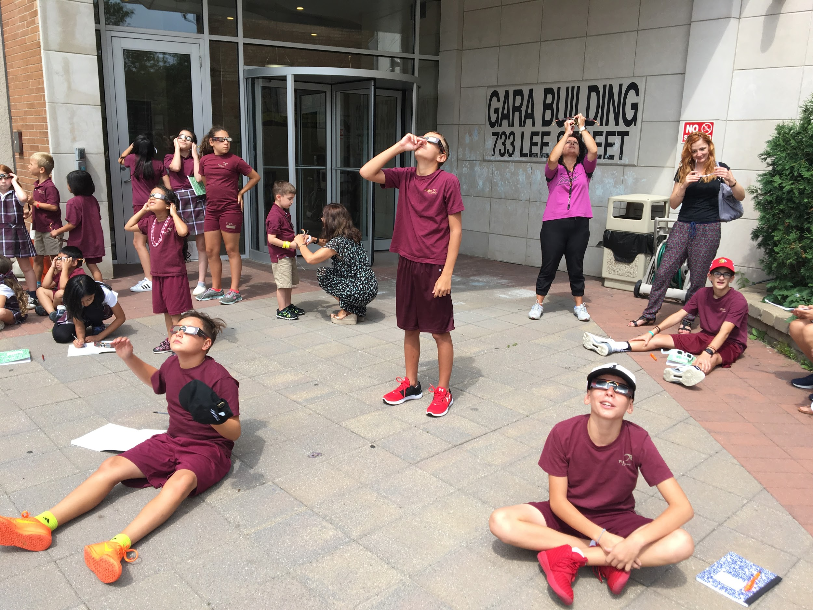
We started the school year off by watching the total solar eclipse with the entire school. The students were excited to be apart of one of nature’s most awe-inspiring sights. Before viewing the students took a short what do you know about the eclipse, they were able to see what one another knew about the eclipse as well as what they still needed to learn before we went outside for the viewing. While taking this short multiple choice what do you know, it gave the students an opportunity to refresh and learn new terminology that is used to describe the eclipse. Terms such as Umbra, Penumbra, and Antumbra.

Entrepreneurship~
This week the students have been working hard on their new ideas for our Friday morning coffee shop. Last year, the middle school class started a weekly coffee shop that offered coffee, tea, and espressos to the adults that enter the GARA building. This year the students wanted to revamp the previous years coffee shop and give it a new name. While discussing what goes into running the coffee shop the students started asking questions and thinking deeper into the idea of what it takes to open and run a business. After hearing the students ideas and questions I advised them to look at some of the major companies that they know of and see how their CEO’s and presidents run such successful businesses. As a class we have decided that after much research we would like to create our own businesses and create a version of “Shark Tank” within our own classroom. The students have been placed into 3 groups of 3 and are in the process of creating their own product, looking at what their consumers will be interested in, the demographics of their consumers / placement of their business, and what their marketing targets will be. I believe that by introducing entrepreneurship to our young adults and encouraging students to develop these skills will better prepare them for their future.
~ please ask your child about their group's business plans!
Root word challenges~
Each morning the students were given a challenge using root words. The challenge contained connecting the root to its meaning as well as finding a word that contained the root. To their surprise the students were able to use their greek speaking skills to their advantage and figure out some of the words meanings. We will continue to do this not so that the students can learn Latin and Greek as a spoken language, but so they can learn more about the English language. English literally has its roots in Latin and Greek, more than half of English words have Latin or Greek root words. In fact, I learned more about using root words to determine the meaning of words from my science classes than my language arts courses. I still use this when I encounter new words. I want my children to have this skill, also.

Buddy time~
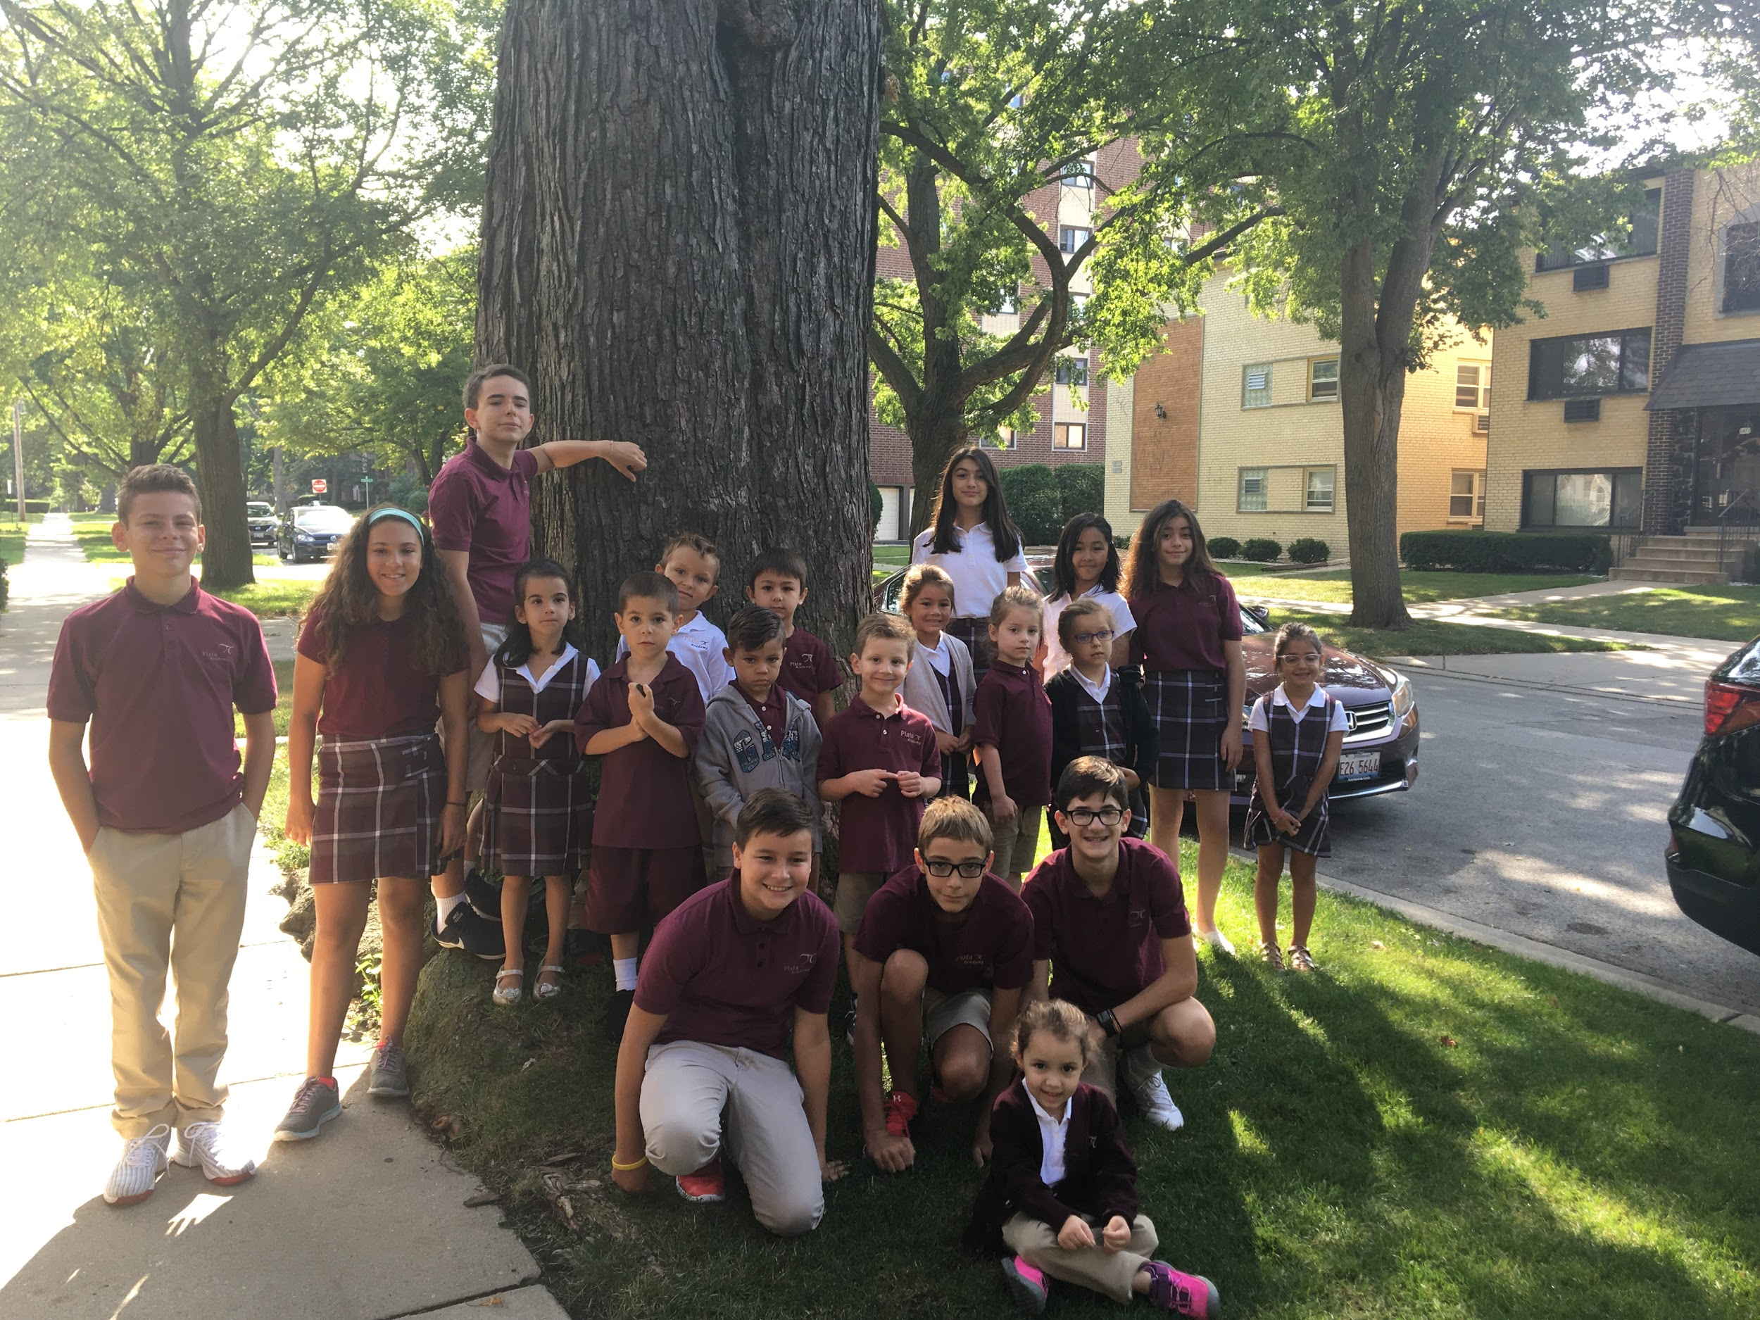
This year we will be partnering up with Ms. Anna & Ms. Leslie's classes for buddy time. We will be meeting with each class every other week! We have decided that instead of reading each week we will be doing art projects with the students, STEM activities, and daily activities that give both the older and younger kids the ability to learn from one another.
~ We started our buddies this week with Ms. Anna’s class. We decided to go on a nature walk and choose a tree that we will be studying throughout the year. We will be joining Ms. Anna’s class on a monthly walk to visit the tree and see the changes that are occurring as the seasons change. This gives the middle school students to study the change in weather and its effect on nature while teaching the younger students the natural changes that develop in trees as the seasons change.

Reminders:
August
8/25 (Friday): PTO Ice Cream Social 3:10pm
8/28 (Monday): After School Activities Begin
8/30 (Wednesday): 1st PTO Meeting 7:00pm (all parents welcome)
September
9/1 (Friday): Girl Scouts 3:10-4:45pm
9/4 (Monday): NO SCHOOL (Labor Day)
9/8 (Friday): Adventure Club Group 1 (PK4-2nd) 3:10-4:30
9/12 (Tuesday): Picture Day
9/15 (Friday): Adventure Club Group 2 (2nd-8th) 3:10-4:30

Hope you have a great weekend,
Ms. Alexandra

“Failure should be our teacher, not our undertaker. Failure is delay, not defeat. It is a temporary detour, not a dead end. Failure is something we can avoid only by saying nothing, doing nothing, and being nothing.” - Denis Waitley

