August 25th, 2017
Welcome to the Spanish corner!
Let’s hear a big hurray to a wonderful first day of our Clases de Español! I am so glad to see all the new faces at Plato, and all the familiar faces as well. We are all a big familia at Plato, and it won’t be hard to feel welcomed in our class. We began to know each other by telling our names and we talked about our feelings, in order to give us an idea how anxious some of us feel on our first class of Spanish. We talked about Palabras Magicas/ Magic Words that we will be using in every class and we will be adding more and more every week. We started practicing Por favor y Gracias / Please and Thank you. We also talked about the way we will interact inside of the classroom, with the 2 golden rules when learning a second language:
1. Try, try, try! We all learn from our mistakes, and
2. Avoid making fun of others when they are trying.
The latter is particularly important since we are trying to build confidence on every student.
The younger kids enjoyed exploration with the color azul/ blue, we played with some slime and made some great discoveries: it’s cold to the touch, it’s ooey and gooey, and it flows between our fingers. We could also print our hands on it! For some it was their first experience with slime and it took them a few minutes to fully enjoy it. Some classes also enjoyed looking for the color blue around the classroom.
We talked about our feelings and we told each other if we were Feliz, Triste, o Enojado / Happy, Sad, Upset. The older classes also learned Asustado, Tranquilo, Aburrido, Confundido/ Scared, Calmed, Bored, Confused.
Older kids talked about phrases we commonly use in our class, like Puedo ir al baño?/ Can I go to the bathroom, or Puedo ir a tomar agua?/ Can I go drink some water? No se, No comprendo, No entiendo/ I don’t know, I don’t understand. We also wrote our favorite color and played a game that challenged us to remember everyone’s favorite color. We wrote on a piece of paper some activities that we like or dislike and shared with the class.
Here’s a list of songs we are currently learning:
Prek-4th grade
Buenos Dias / Good morning https://youtu.be/9ZKw5IldE9Y
De que color es?/ What color is it? https://youtu.be/7jBDsWOoWz0
Da una vuelta en tu Lugar/ Turn around on your spot https://youtu.be/-csuoX_uM7U
Cuantos años tienes tu?/ How old are you https://youtu.be/L77RgXiRBB0
Lento may lento/ Slow very slow https://youtu.be/RNeO4MntTaA
Como te llamas? / What’s your name? https://youtu.be/bFIJN5mkRG4
Bailar baila/ Dance dance https://youtu.be/wII6FbAC_4Y
4th-8th graders also sing:
Como estás?/ How are you? https://youtu.be/4vvIU_Jg7e8
Buenos Dias/ Good morning! https://youtu.be/kdDu8pFbnRc
Los colores y numeros/ The colors and numbers https://youtu.be/ZiNFXntWOJw
We will keep on learning more songs each class, depending on the vocabulary we are working on.
Some of this week’s vocabulary:
Hola  Buenos Dias  Como Estas?  Bien/Muy Bien  Mal/ Muy mal  Asi, asi  Como te llamas?  Me llamo _______  Y tu? Y usted?  Como te sientes?  Me siento_________ | Feliz  Triste  Enojado  Asustado  Tranquilo  Niño  Niña  Cuantos?  Donde está______?  Aqui estoy  Colores | Azul/Rojo/Amarillo/Rosa  Morado/Café/Gris/Negro/  Blanco, Naranja/ Morado  Me gusto  No me gusta___  Mi color favorito es_____  Leer/Jugar/Correr/Caminar/ Bailar/ Dormir/Brincar/ Escribir/ Comer/ Beber/Sentar/Parar  Me gusta/ No me gusta

In our class we don’t focus strictly on grammar, we prefer to introduce the Spanish language as conversational and fun as possible.
Here are some websites that I use for songs and/or activities are accessible to you, and most of them are free: Calico, Rockalingua, Basho and Friends, CantaJuego, Sing A Lingo
Any questions? Feel free to email me SorayaCastroF@gmail.com
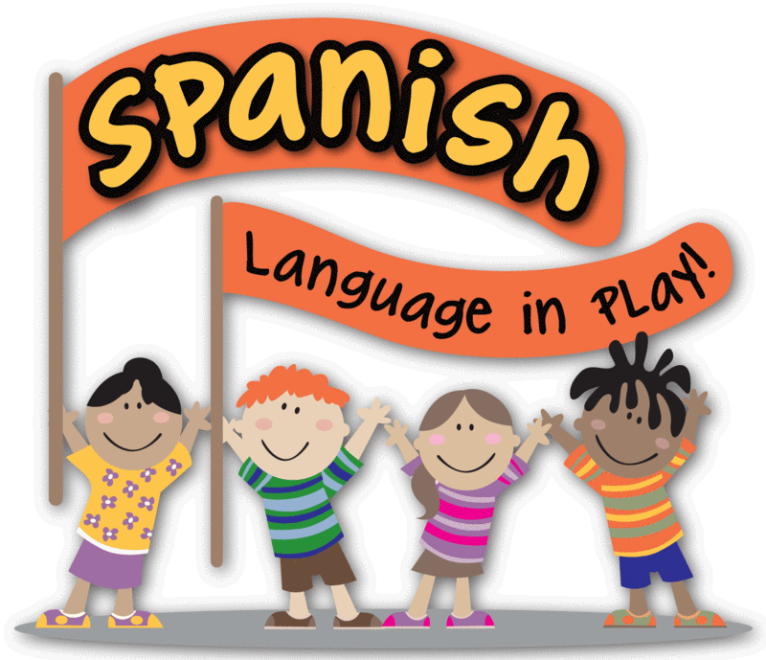
I can’t wait to see how much we’ll learn this year!

Soraya Castro

